Reading Assignment Student Name ___________________

Lecture _____ Date ___________________

Instructions:

Design a concept map on your assigned reading

- Start by thinking about the concept you wish to map (i.e. the different kinds of metabolism employed by different forms of life). Make a list of terms or phrases that relate to this concept. You can go through the sections in the textbook or your class notes and highlight any important terms or phrases that relate to the overarching concept.
- Write the terms on post-it notes, or index cards. Either alone or with a study partner, begin to organize the terms on a large sheet of paper or on a chalkboard according to logical relations between terms. Often it is best to start with the most inclusive terms or concepts at the top of the page and work down, or at the center of the page and work out from the center.
- Once you have the terms organized, draw lines (use pencil to do this initially) that logically connect individual terms or phrases, and write a phrase next to the line that explains the connection. You can also use different colored lines to show distinct “concept routes” within the whole map. Try and make as many connections as you can. If you are working with others this will engender much discussion about how the map should be organized and will reveal where you are not making important connection or are making inaccurate connections.
- Once you have completed your map, remove the post-it notes or index cards, and write the terms/phrases on the sheet of paper. This will give you a permanent record of your concept map. Hand in a copy of your concept map to your instructor.

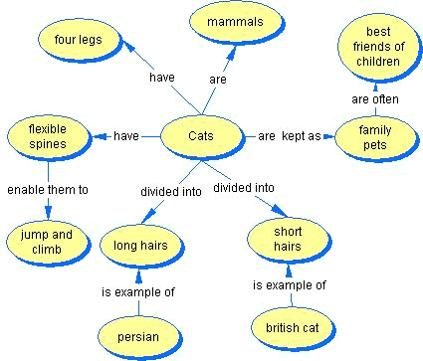
Here is an example taken from http://tutorials.istudy.psu.edu/conceptmaps/conceptmaps_print.html

